Multinomial Test

11/14/2021 18:36

# Abstract

Outcome variable: *continent*  
Null probabilities: *0.2, 0.2, 0.2, 0.2, 0.2*

A Multinomial test is employed to check if the parameters equal *0.2, 0.2, 0.2, 0.2, 0.2*. According to the result, we can reject the null probabilities at the significance level of 0.05.

### Multinomial Test

Multinomial Test determines whether the parameters of a multinomial distribution equal specified values. It is used for categorical data.

# Descriptive Statistics

Table 1 gives the basic information of the analyzing data set. Observations with missing values are removed when calculating. It shows that there is no missing value in the data.

$Table 1.$ Completeness of Data.

|  |  |  |
| --- | --- | --- |
|  | Observation | Incomplete Observation (not used) |
| Number | 994 | 0 |

The pie chart of *continent* is given in Figure 1.

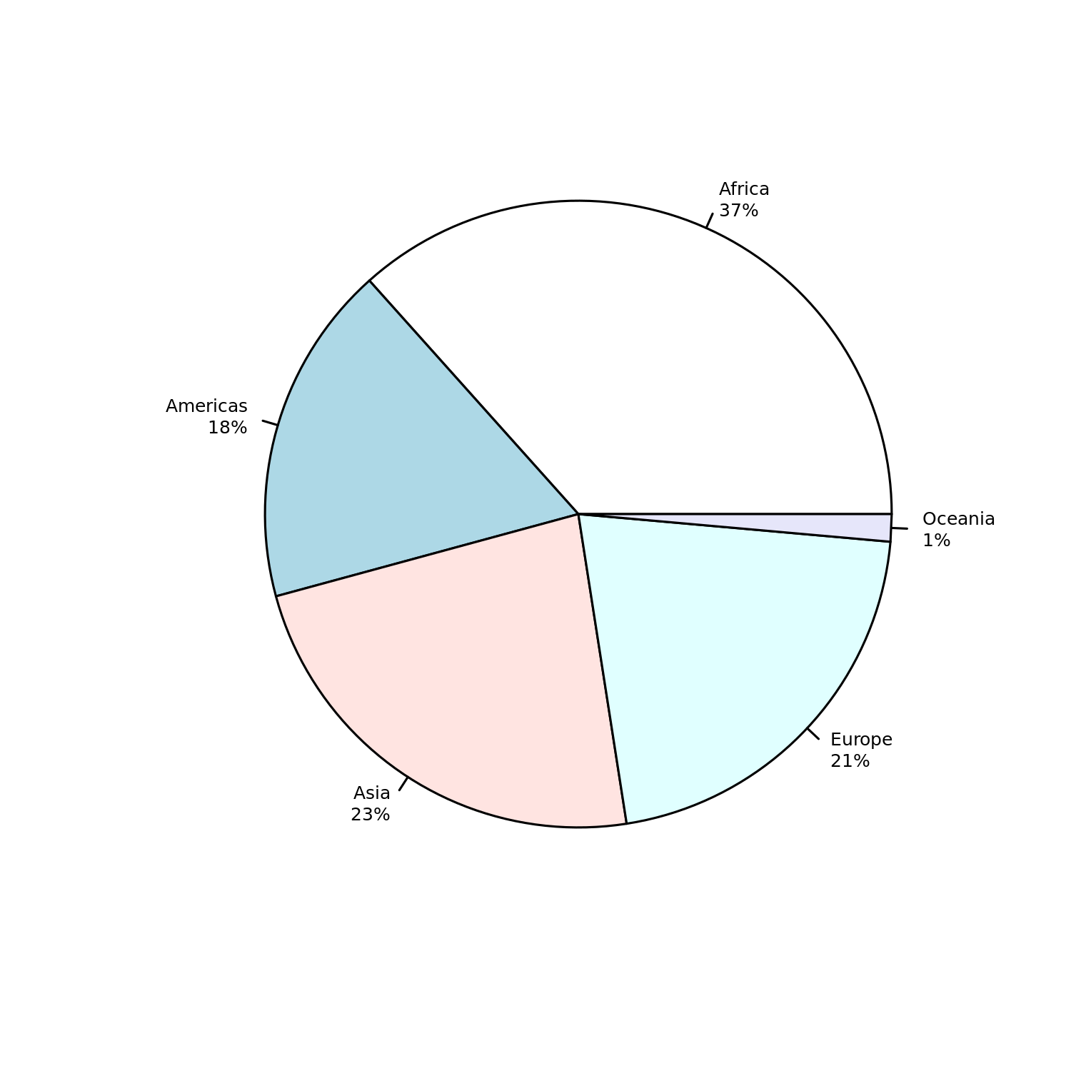

$Figure 1.$ Pie chart for *continent*.

The detailed frequencies of *continent* is given in Table 2.

$Table 2.$ Frequencies of continent.

|  |  |  |  |  |
| --- | --- | --- | --- | --- |
| continent=Africa | continent=Americas | continent=Asia | continent=Europe | continent=Oceania |
| 364 | 175 | 231 | 210 | 14 |

# Results

A multinomial test is performed (Read and Cressie 2012). Chi-squared test is employed for an approximate test. Table 3 shows the results

$Table 3.$ Result of Multinomial Test.

|  |  |  |
| --- | --- | --- |
| Test Method | df | p-value |
| Chi-squared goodness of fit | 4 | 0 |

Here, the p-value is 1.6^{-67}, which means there is a significant difference between the distribution parameters and the null values at the level of 0.05.

Confidence intervals for multinomial proportions are calculated simultaneously and given in Table 4.

$Table 4.$ Estimated Probability and its 95% Confidence Interval.

|  |  |  |  |
| --- | --- | --- | --- |
|  | Estimated Probability | Lower | Upper |
| continent=Africa | 0.366 | 0.334 | 0.400 |
| continent=Americas | 0.176 | 0.144 | 0.210 |
| continent=Asia | 0.232 | 0.200 | 0.266 |
| continent=Europe | 0.211 | 0.179 | 0.245 |
| continent=Oceania | 0.014 | 0.000 | 0.048 |

After a global multinomial test for given probabilities, pairwise comparisons are performed using chi-squared tests. The *p*-value adjustment method is fdr.

$Table 5.$ Pairwise Comparisons.

|  |  |  |  |  |  |
| --- | --- | --- | --- | --- | --- |
|  | Observed | Expected | Chi | p-value |  |
| continent=Africa | 364 | 198.8 | 171.5985915 | 0.0000000 | *** |
| continent=Americas | 175 | 198.8 | 3.5616197 | 0.0739125 | . |
| continent=Asia | 231 | 198.8 | 6.5193662 | 0.0177843 | * |
| continent=Europe | 210 | 198.8 | 0.7887324 | 0.3744837 |  |
| continent=Oceania | 14 | 198.8 | 214.7323944 | 0.0000000 | *** |

It shows the comparison results together with the observed and expected proportions using exact binomial tests. A small p-value (less than 0.05) means there is a significant difference between the population proportion and the expected proportion.

# Conclusions

Based on the above results, we can get the following conclusion:

* There is no sufficient evidence to say the parameters of the multinomial distribution isn’t equal to 0.2, 0.2, 0.2, 0.2, 0.2 at the significant level of 0.05.

# Terminologies

***Null hypothesis***: In inferential statistics, the null hypothesis is a general statement or default position that there is no relationship between two measured phenomena or no association among groups.

***p-value***: In statistical hypothesis testing, the *p*-value is, for a given statistical model, the probability that, when the null hypothesis is true, the statistical summary would be greater than or equal to the actual observed results.

# References

Read, Timothy RC, and Noel AC Cressie. 2012. *Goodness-of-Fit Statistics for Discrete Multivariate Data*. Springer Science & Business Media.